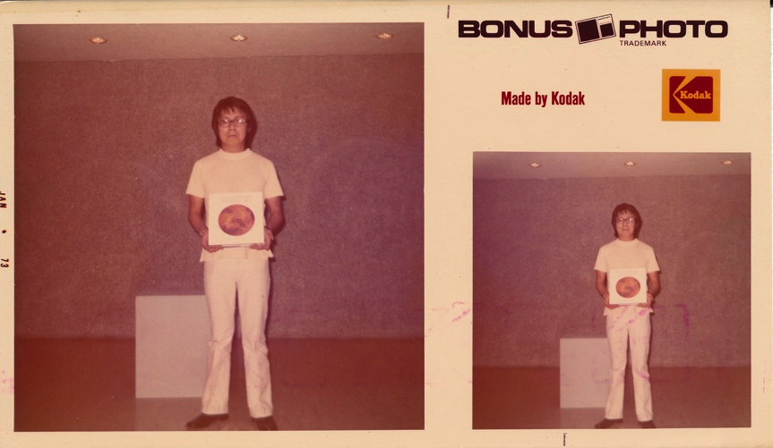

Figure 2.1 Roberto Chabet, *Tearing to Pieces*, performance, Cultural Center of the Philippines, 1973, (Photograph by Yolanda Johnson)



Figure 2.2 Roberto Chabet, *Tearing to Pieces*, performance, Cultural Center of the Philippines, 1973, (Photograph by Yolanda Johnson)

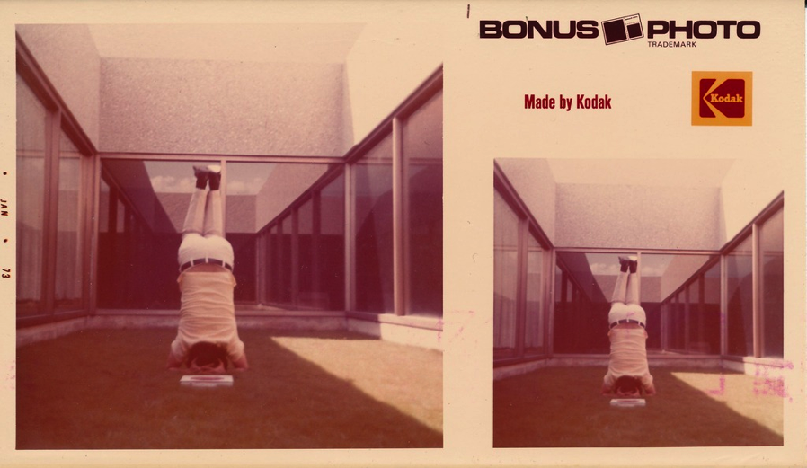

Figure 2.3 Roberto Chabet, *Tearing to Pieces*, performance, Cultural Center of the Philippines, 1973, (Photograph by Yolanda Johnson)



Figure 2.4 Roberto Chabet, *Tearing to Pieces*, performance, Cultural Center of the Philippines, 1973, (Photograph by Yolanda Johnson)

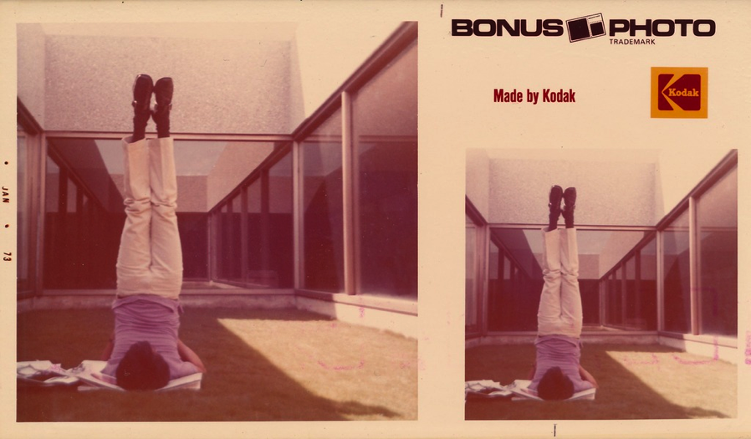

Figure 2.5 Roberto Chabet, *Tearing to Pieces*, performance, Cultural Center of the Philippines, 1973, (Photograph by Yolanda Johnson)

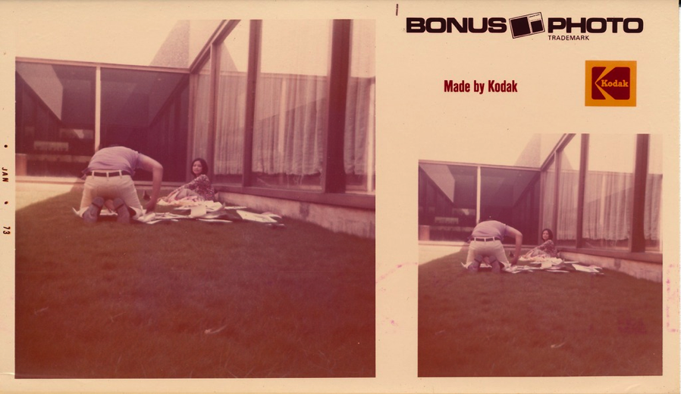

Figure 2.6 Roberto Chabet, *Tearing to Pieces*, performance, Cultural Center of the Philippines, 1973, (Photograph by Yolanda Johnson)

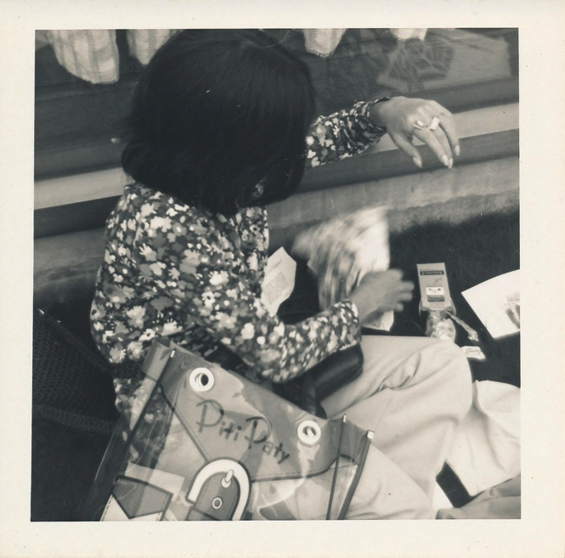

Figure 2.7 Roberto Chabet, *Tearing to Pieces*, performance, Cultural Center of the Philippines, 1973, (Photograph by Yolanda Johnson)

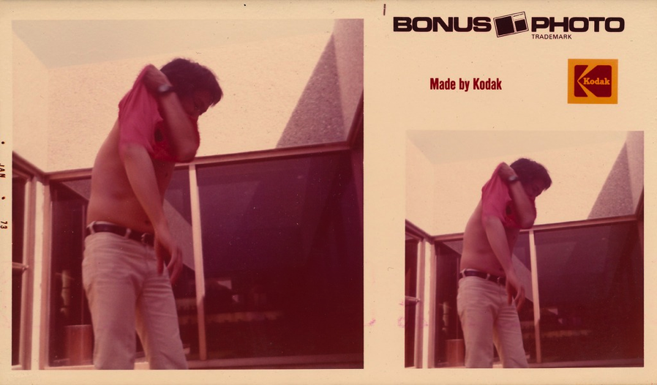

Figure 2.8 Roberto Chabet, *Tearing to Pieces*, performance, Cultural Center of the Philippines, 1973, (Photograph by Yolanda Johnson)

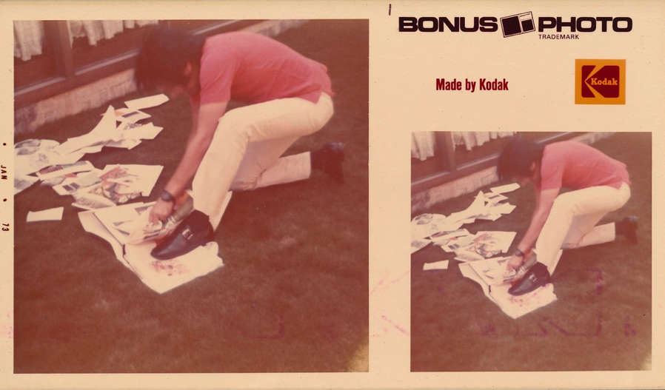

Figure 2.9 Roberto Chabet, *Tearing to Pieces*, performance, Cultural Center of the Philippines, 1973, (Photograph by Yolanda Johnson)

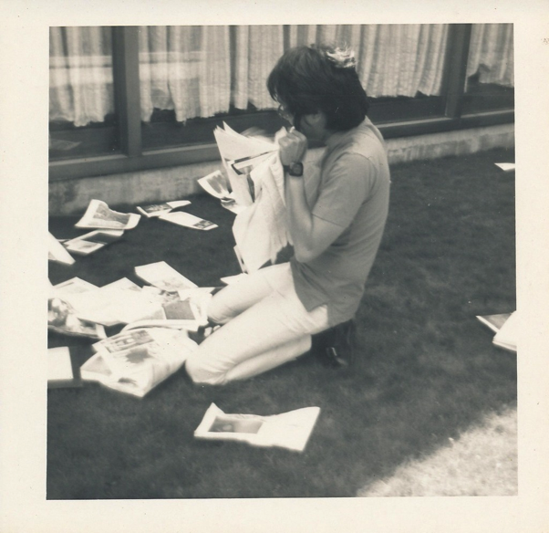

Figure 2.10 Roberto Chabet, *Tearing to Pieces*, performance, Cultural Center of the Philippines, 1973, (Photograph by Yolanda Johnson)

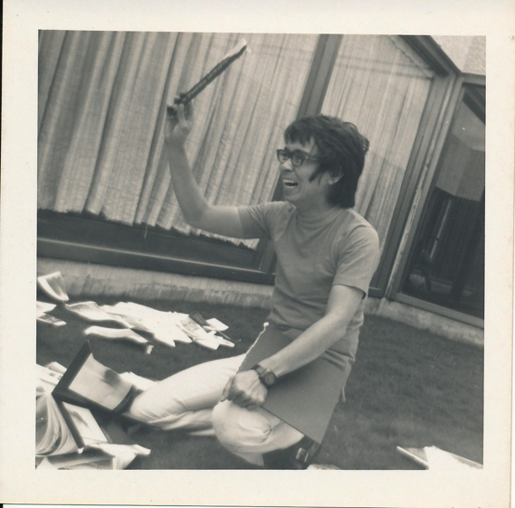

Figure 2.11 Roberto Chabet, *Tearing to Pieces*, performance, Cultural Center of the Philippines, 1973, (Photograph by Yolanda Johnson)

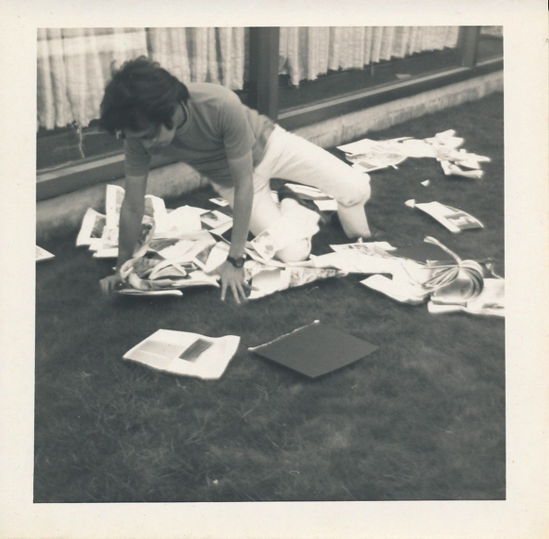

Figure 2.12 Roberto Chabet, *Tearing to Pieces*, performance, Cultural Center of the Philippines, 1973, (Photograph by Yolanda Johnson)

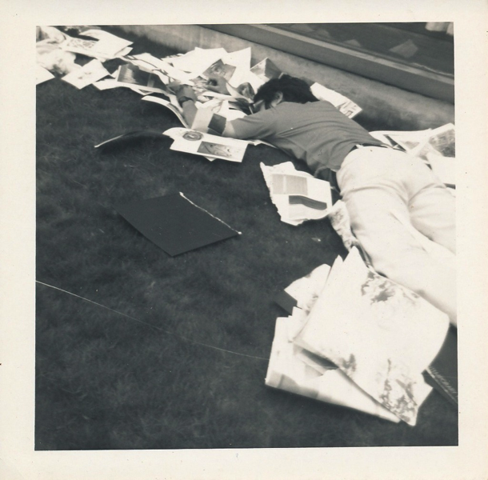

Figure 2.13 Roberto Chabet, *Tearing to Pieces*, performance, Cultural Center of the Philippines, 1973, (Photograph by Yolanda Johnson)

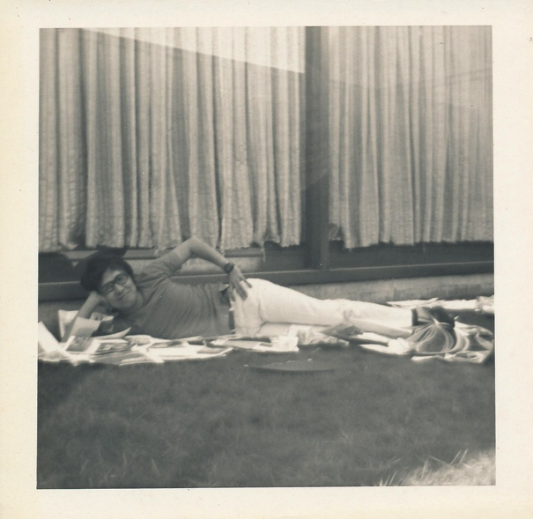

Figure 2.14 Roberto Chabet, *Tearing to Pieces*, performance, Cultural Center of the Philippines, 1973, (Photograph by Yolanda Johnson)

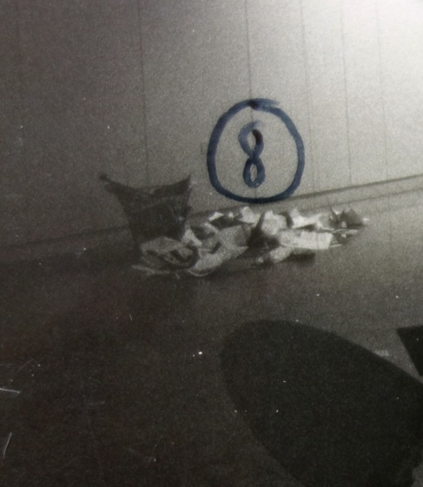

Figure 2.15 Roberto Chabet, Yoli Laudico, and Joy Dayrit, *Tearing to Pieces*, (artists specified medium, “Philippine Contemporary Art”) waste basket, torn pieces of book

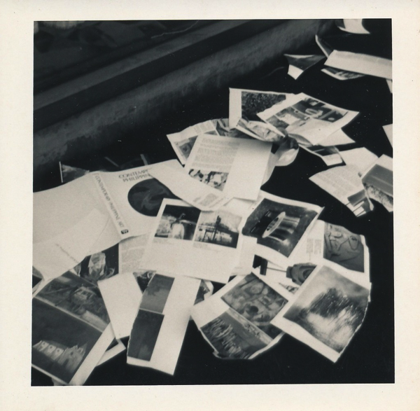

Figure 2.16 Roberto Chabet, *Tearing to Pieces*, performance, Cultural Center of the Philippines, 1973, (Photograph by Yolanda Johnson)

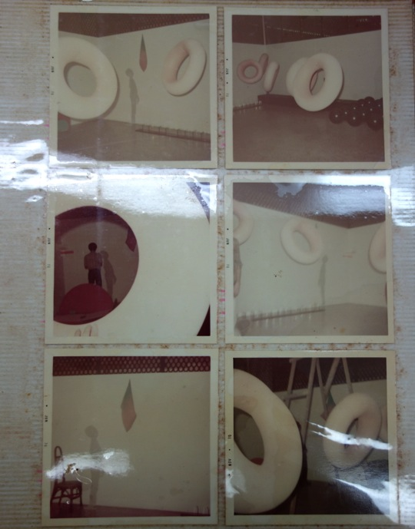

Figure 2.17 Liwayway Recapping Co. photo album leaf from final Print Gallery Exhibition,1970

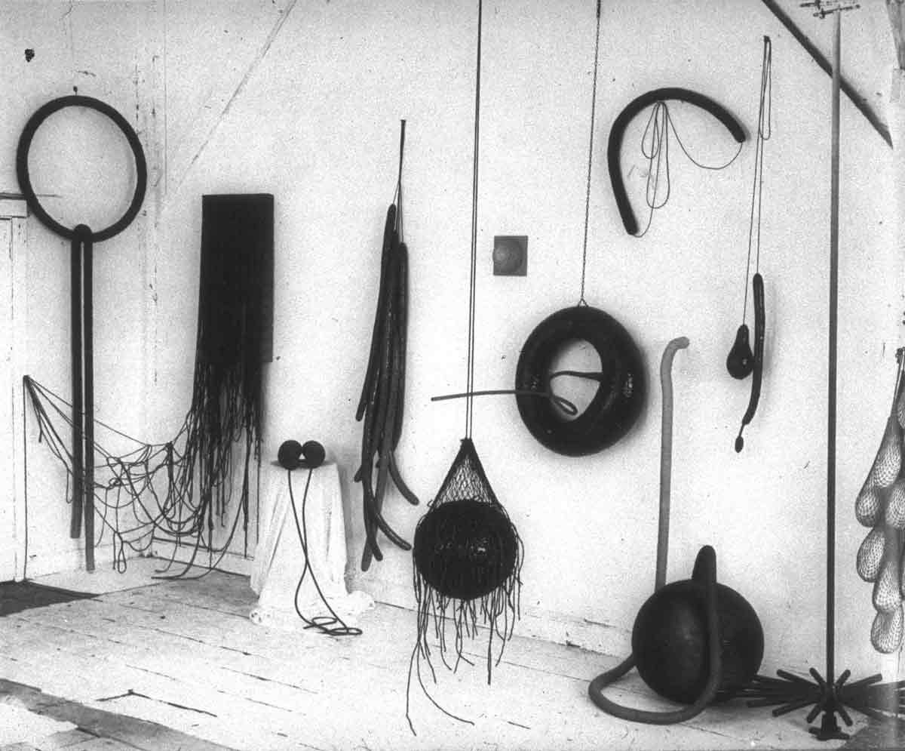

Figure 2.18 Eva Hesse, Photograph of Hesse’s studio, early 1966

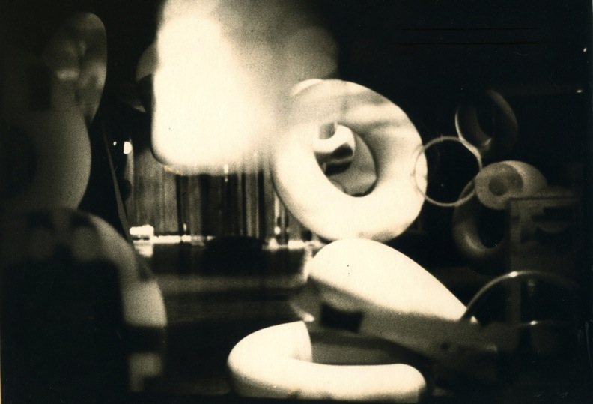

Figure 2.19 Liwayway Recapping Co., *Illuminations*, installation view, Cultural Center of the Philippines, 1970



Figure 2.20 Roberto Chabet, *Kite Traps*, interior tire tube and plywood,1973 (Photograph by Nathaniel Gutierrez)



Figure 2.21 Roberto Chabet, *Kite Traps*, interior tire tube and plywood, 1973 (Photograph by Nathaniel Gutierrez)

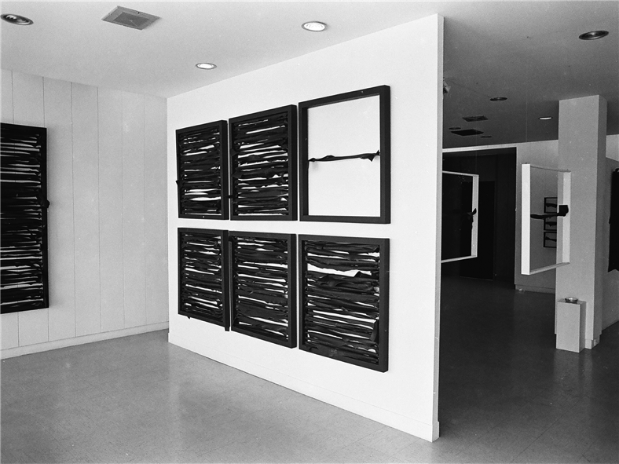

Figure 2.22 Roberto Chabet, *Kite Traps*, installation view at *New Works* (1973), interior tire tube and plywood, 1973

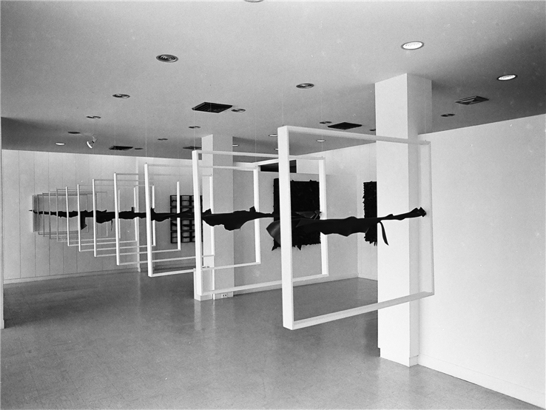

Figure 2.23 Roberto Chabet, *Sky Horizons*, installation view at *New Works* (1973), interior tire tube and plywood, 1973 (Photograph by Nathaniel Gutierrez)

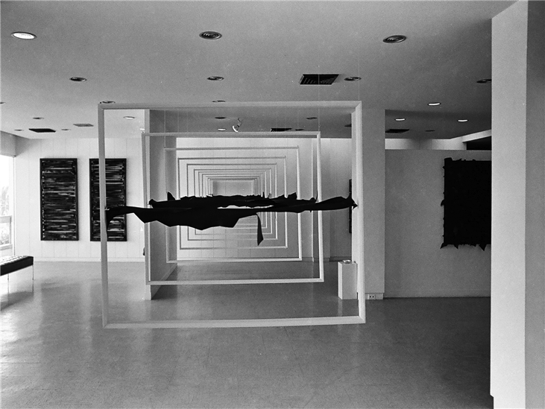

Figure 2.24 Roberto Chabet, *Sky Horizons*, installation view at *New Works* (1973), interior tire tube and plywood 1973 (Photograph by Nathaniel Gutierrez)

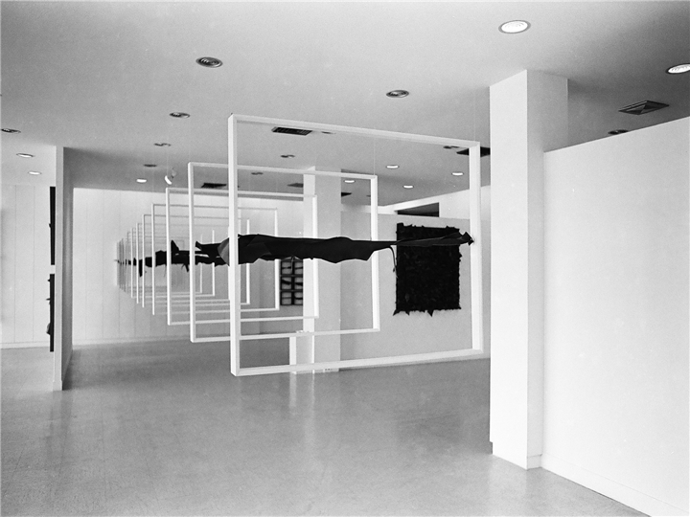

Figure 2.25 Roberto Chabet, *Sky Horizons*, installation view at *New Works* (1973), interior tire tube and plywood, 1973 (Photograph by Nathaniel Gutierrez)

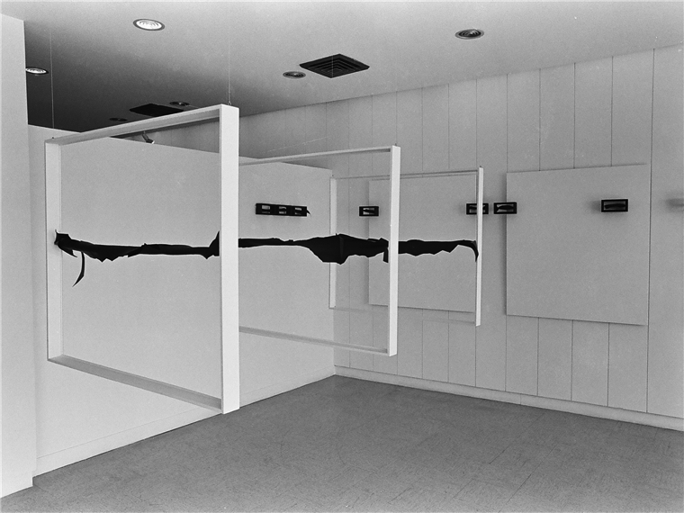

Figure 2.26 Roberto Chabet, *Sky Horizons*, installation view at *New Works* (1973), interior tire tube and plywood, 1973 (Photograph by Nathaniel Gutierrez)

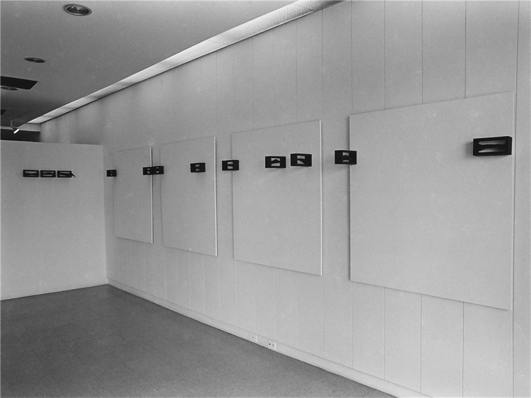

Figure 2.27 Roberto Chabet, *New Works* exhibition view (1973), 1973 (Photograph by Nathaniel Gutierrez)

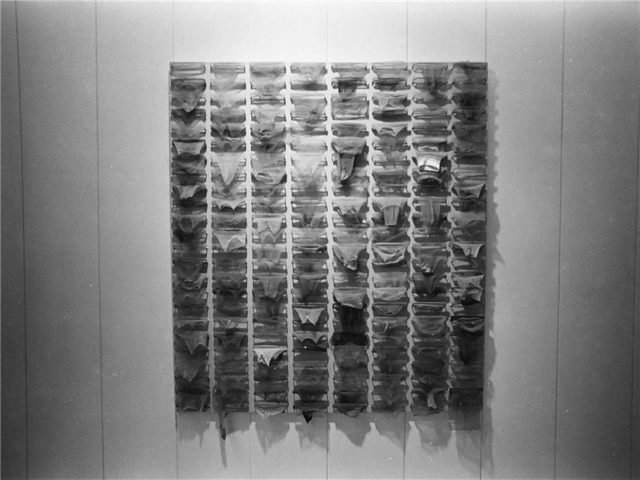

Figure 2.28 Roberto Chabet, *Pink Painting*, nylon stockings on plywood, 1973 (Photograph by Nathaniel Gutierrez)

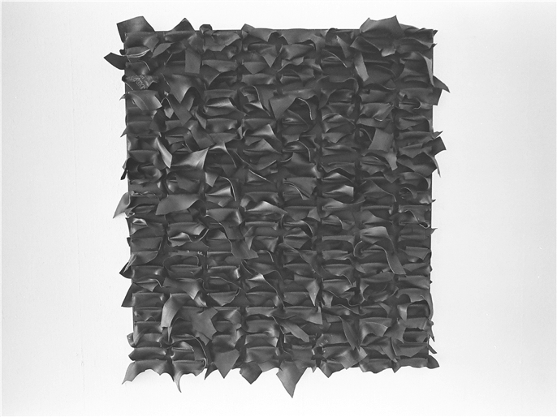

Figure 2.29 Roberto Chabet, no title, interior tire tube and plywood 1973 (Photograph by Nathaniel Gutierrez)

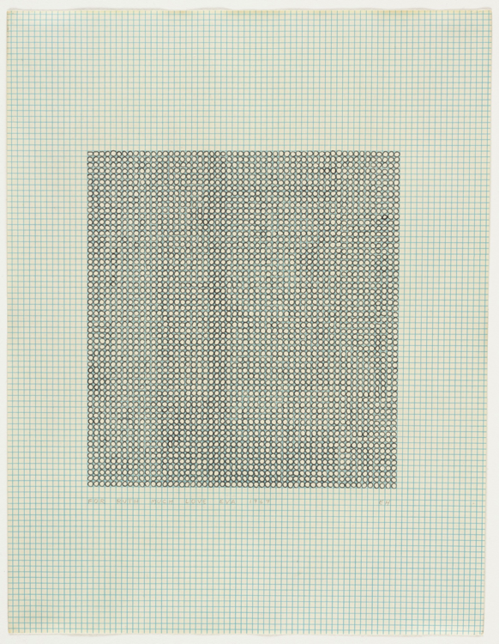

Figure 2.30 Eva Hesse, *No Title*, ink on graph paper, 11 7/8 x 8 1/4”, 1967

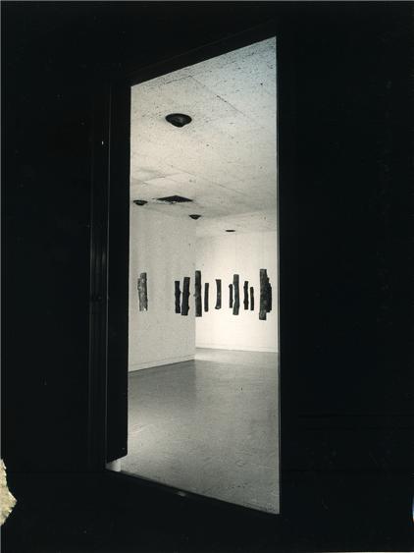

Figure 2.31 Roberto Chabet, *Bakawan*, installation view (1974), 1974 (Photograph by Nathaniel Gutierrez)

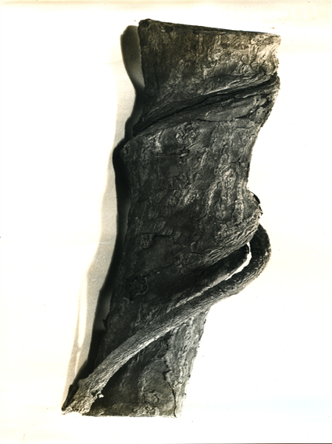

Figure 2.32 Photograph of single *Bakawan*, 1974